Experiment 1: Installation, Environment Setup and starting with C language
- Write a C program to print “Hello World”
INPUT:
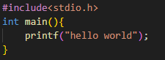
OUTPUT:
- Write a C Program to print the address in multiple lines (new line).
INPUT:
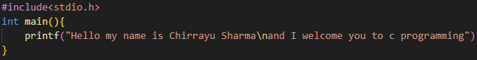
OUTPUT:
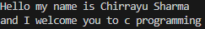
- Write a program that prompts the user to enter their name and age.
INPUT:
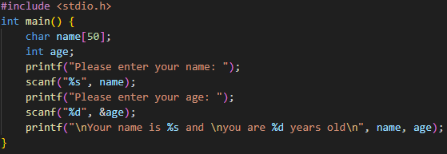
OUTPUT:
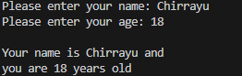
- Write a C program to add two numbers, take number from user.
INPUT:
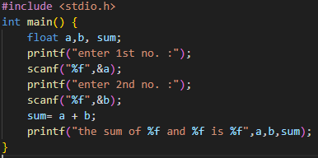
OUTPUT:
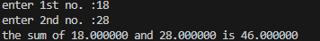

Experiment 2: Operators
- WAP a C program to calculate the area and perimeter of a rectangle based on its length and width.

INPUT:
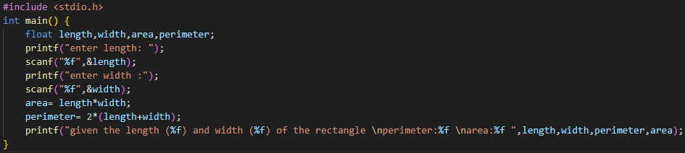
OUTPUT:
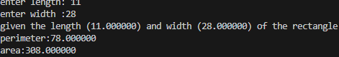

- WAP a C program to Convert temperature from Celsius to Fahrenheit using the formula: F = (C * 9/5) + 32.

INPUT:
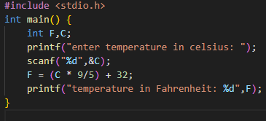
OUTPUT:
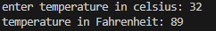
Experiment 3.1: Conditional Statements
- WAP to take check if the triangle is valid or not. If the validity is established, do check if the triangle is isosceles, equilateral, right angle, or scalene. Take sides of the triangle as input from a user.

INPUT:
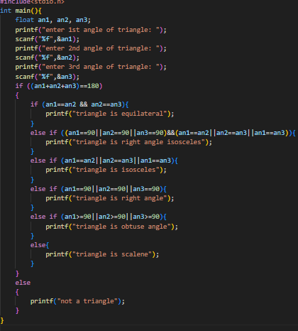
OUTPUT:
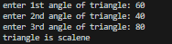

- WAP to compute the BMI Index of the person and print the BMI values as per the following ranges. You can use the following formula to compute BMI= weight(kgs)/Height(Mts)*Height(Mts).
 | BMI
Starvation | <15
Anorexic | 15.1 to 17.5
Underweight | 17.6 to 18.5
Ideal | 18.6 to 24.9
Overweight | 25 to 25.9
Obese | 30 to 39.9
Morbidity Obese | 40.0 above

INPUT:
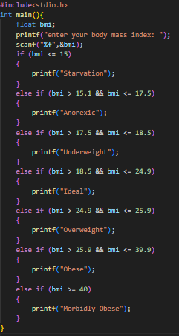
OUTPUT:

- WAP to check if three points (x1,y1), (x2,y2) and (x3,y3) are collinear or not.
INPUT:
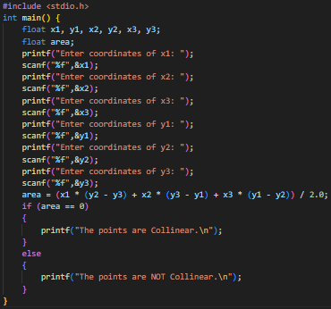
OUTPUT:
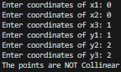

- According to the gregorian calendar, it was Monday on the date 01/01/01. If Any year is input through the keyboard write a program to find out what is the day on 1st January of this year.
INPUT:
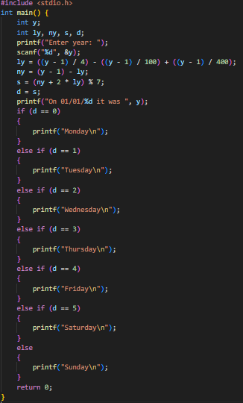
OUTPUT:
VERIFICATION:
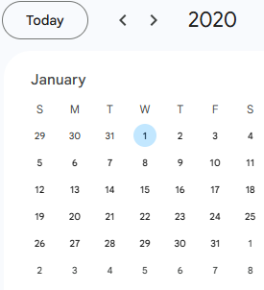
- WAP using ternary operator, the user should input the length and breadth of a rectangle, one has to find out which rectangle has the highest perimeter. The minimum number of rectangles should be three.

INPUT:
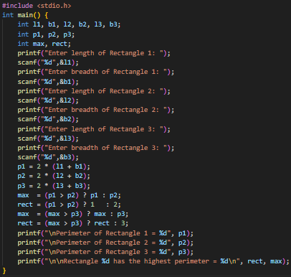
OUTPUT:
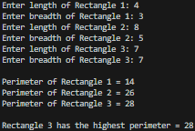

Experiment 3.2: Loops

- WAP to enter numbers till the user wants. At the end, it should display the count of positive, negative, and Zeroes entered.

INPUT:
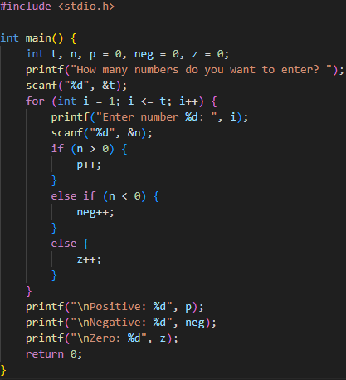
OUTPUT:
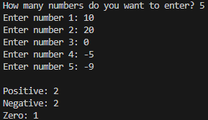
- WAP to print the multiplication table of the number entered by the user. It should be in the correct formatting. Num * 1 = Num
INPUT:
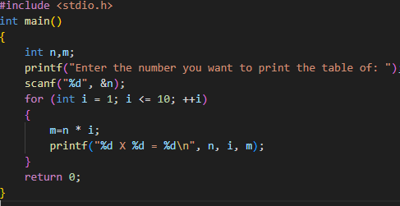
OUTPUT:
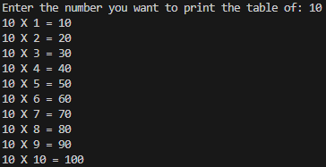

- WAP to generate the following set of output.
- 1
23
456
INPUT:
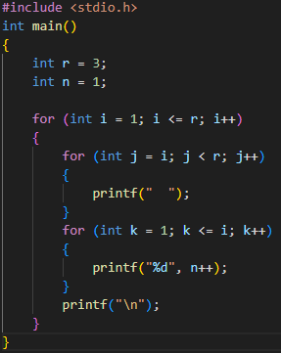
OUTPUT:
Experiment 4: Variable and Scope of Variable

- Declare a global variable outside all functions and use it inside various functions to understand its accessibility
INPUT:
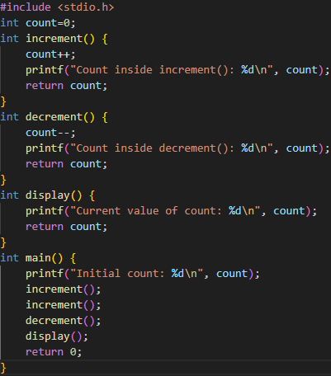
OUTPUT:
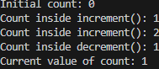

- Declare a local variable inside a function and try to access it outside the function. Compare this with accessing the global variable from within the function.
INPUT:
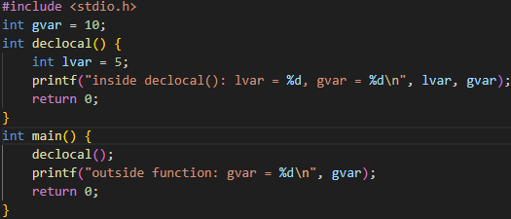
OUTPUT:
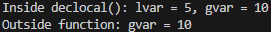

- Declare variables within different code blocks (enclosed by curly braces) and test their accessibility within and outside those blocks.
INPUT:
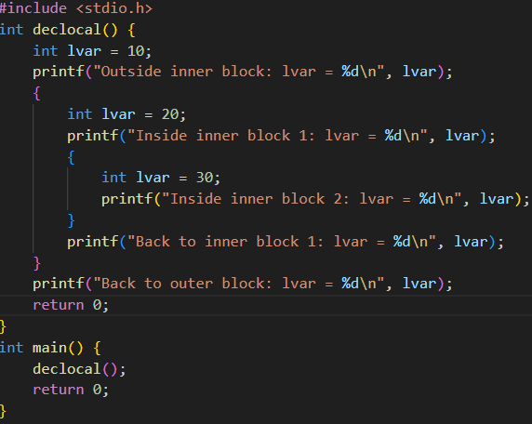
OUTPUT:
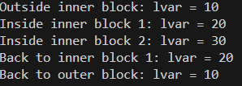

Experiment 5: Array
- WAP to read a list of integers and store it in a single dimensional array. Write a C program to print the second largest integer in a list of integers.
INPUT:
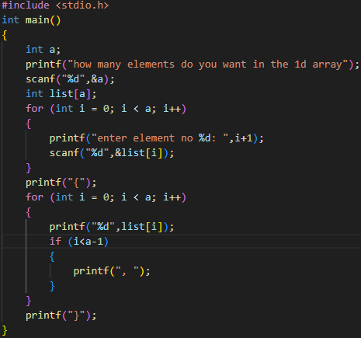
OUTPUT:
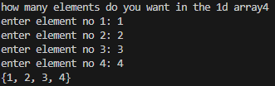

- WAP to read a list of integers and store it in a single dimensional array. Write a C program to count and display positive, negative, odd, and even numbers in an array
INPUT:
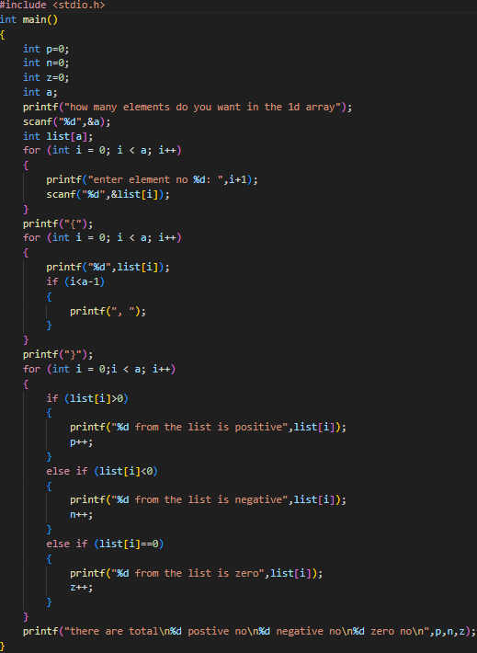
OUTPUT:
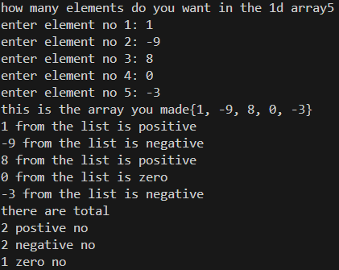

- WAP to read a list of integers and store it in a single dimensional array. Write a C program to find the frequency of a particular number in a list of integers
INPUT:
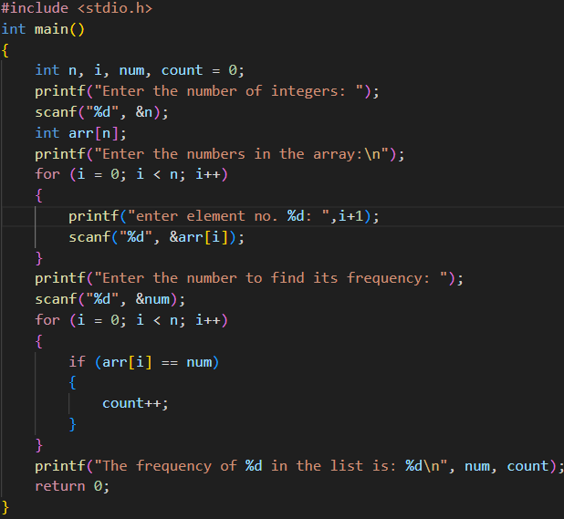
OUTPUT:
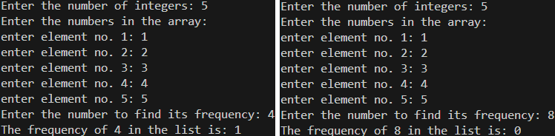

- WAP that reads two matrices A (m x n) and B (p x q) and computes the product A and B. Read matrix A and matrix B in row major order respectively. Print both the input matrices and resultant matrix with suitable headings and output should be in matrix format only. Program must check the compatibility of orders of the matrices for multiplication. Report appropriate message in case of incompatibility
INPUT:
OUTPUT:

Experiment 6: Functions
- Develop a recursive and non-recursive function FACT(num) to find the factorial of a number, n!, defined by FACT(n) = 1, if n = 0. Otherwise, FACT(n) = n * FACT(n-1). Using this function, write a C program to compute the binomial coefficient. Tabulate the results for different values of n and r with suitable messages.
INPUT:
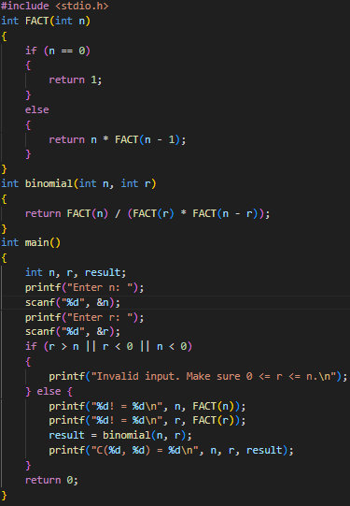
OUTPUT:
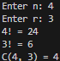

- Develop a recursive function GCD (num1, num2) that accepts two integer arguments. Write a C program that invokes this function to find the greatest common divisor of two given integers.
INPUT:

OUTPUT

- Develop a recursive function FIBO (num) that accepts an integer argument. Write a C program that invokes this function to generate the Fibonacci sequence up to num.
INPUT:

OUTPUT:

- Develop a C function ISPRIME (num) that accepts an integer argument and returns 1 if the argument is prime, a 0 otherwise. Write a C program that invokes this function to generate prime numbers between the given ranges.
INPUT:

OUTPUT:

- Develop a function REVERSE (str) that accepts a string argument. Write a C program that invokes this function to find the reverse of a given string.
INPUT:

OUTPUT:

